NYAYSETU: AN AI-ASSISTED LEGAL SUGGESTION SYSTEM

A project submitted
in partial fulfilment of the requirements for the degree of Bachelor of
Technology in Computer Science and Engineering by
Anupam Kumar Singh (2023305089) Akshay Pratap Singh (2023409091) Prince Kumar (2023284684)



Supervised by:
Prof. (Dr.) Velayudham Sathiyasuntharam Professor, CSE

NOVEMBER, 2026
DEPARTMENT OF COMPUTER SCIENCE & ENGINEERING SHARDA SCHOOL OF ENGINEERING AND TECHNOLOGY SHARDA UNIVERSITY, GREATER NOIDA

CERTIFICATE

This is to certify that the report entitled "NYAYSETU: AN AI-ASSISTED LEGAL SUGGESTION SYSTEM" submitted by "Anupam Kumar Singh (2023305089), Akshay Pratap Singh (2023409091) and Prince Kumar (2023284684)" to Sharda University, towards the fulfilment of requirements of the degree of "Bachelor of Technology", is a record of bona fide project work carried out by them in the Department of Computer Science & Engineering, Sharda School of Engineering and Technology, Sharda University.
The report describes the current web-application foundation and the proposed AI-assisted legal-information workflow. Functionality explicitly identified as planned has not been represented as completed or experimentally validated.

Signature of the Guide
Name: Prof. (Dr.) Velayudham Sathiyasuntharam Designation: Professor, CSE

Signature of Head of Department Name: Prof (Dr.) Jayant Shekhar Place: Sharda University
Date:

Signature of External Examiner Date:

ACKNOWLEDGEMENT

A major project is an important opportunity for learning, research and professional development. We express our sincere gratitude to everyone who supported us during the development of NyaySetu.
We thank the Head of the Department of Computer Science & Engineering and Sharda School of Engineering and Technology, Sharda University, for providing the opportunity and academic environment to undertake this project.
We are especially grateful to our supervisor, Prof. (Dr.) Velayudham Sathiyasuntharam, Professor, CSE, for his guidance, valuable feedback, encouragement and continued review of the project. His suggestions helped us refine the project objectives, research direction, architecture and documentation.
We also thank our faculty members, classmates and all those who contributed directly or indirectly to the completion of the project work.

Name and signature of Students:
Anupam Kumar Singh (2023305089) Akshay Pratap Singh (2023409091) Prince Kumar (2023284684)

ABSTRACT

Access to legal assistance remains difficult for many individuals because of high consultation costs, limited awareness of legal rights, complex legal procedures and geographical barriers. People commonly describe their problems in everyday language rather than formal legal terminology, and may not know which legal category or professional is relevant. This project presents NyaySetu, an AI-assisted legal-information and lawyer-referral platform intended to make preliminary legal information more approachable.
The proposed platform combines a web application foundation with a planned natural-language legal-query workflow. The current technical foundation includes a Next.js/TypeScript frontend, FastAPI backend, PostgreSQL persistence, authentication and role-based access for client, lawyer and administrator roles. The planned AI layer includes natural-language preprocessing, legal-query classification, knowledge retrieval and bounded informational guidance. A further planned component is the connection of users with suitable legal professionals based on profiles and specializations.
Candidate classification approaches identified in the research include TF-IDF features with Multinomial Naive Bayes and a linear Support Vector Machine. These are proposed baselines only. A representative labelled legal-query dataset has not yet been assembled, and the candidate models have not been trained or evaluated for NyaySetu. Therefore, no classification accuracy, model performance or user-outcome improvement is claimed in this report.
The report documents the project motivation, literature survey, research gap, requirements, iterative development approach, proposed architecture, conceptual data design, feasibility and implementation status. Privacy, source verification, clear disclaimers and human professional involvement are treated as essential safeguards. NyaySetu is intended to provide general legal information and is not a substitute for advice from a qualified lawyer.
Keywords: Artificial Intelligence, Natural Language Processing, Legal Technology, Machine Learning, Legal-Query Classification, Legal Assistance, Lawyer Referral.

CONTENTS

SECTION / HEADING | PAGE
TITLE | i
CERTIFICATE | ii
ACKNOWLEDGEMENT | iii
ABSTRACT | iv
CONTENTS | v
LIST OF FIGURES | vi
LIST OF TABLES | vii
LIST OF ABBREVIATIONS | viii
CHAPTER 1: INTRODUCTION | 9
1.1 Problem Statement | 10
1.2 Project Overview | 10
1.3 Project Objectives | 10
1.4 Expected Outcome | 11
1.5 Hardware & Software Specifications | 11
1.6 Other Non-Functional Requirements | 11
1.7 Report Outline | 12
CHAPTER 2: LITERATURE SURVEY | 13
2.1 Existing Work | 14
2.2 Related Work | 14
2.3 Research Gap | 15
2.4 Proposed System | 15
2.5 Feasibility Study | 16
CHAPTER 3: SYSTEM DESIGN & ANALYSIS | 17
3.1 Project Perspective | 18
3.2 Performance Requirements | 18
3.3 System Features | 19
3.4 Methodology | 20
3.5 Testing Process | 24
CHAPTER 4: RESULTS AND OUTPUTS | 26
4.1 Current Implementation Status | 27
4.2 Architecture and Design Outputs | 27
4.3 Requirements and Progress Summary | 27
4.4 Discussion and Limitations | 28
CHAPTER 5: CONCLUSION | 29
5.1 Conclusion | 30
5.2 Future Scope | 30
CHAPTER 6: REFERENCES | 32
ANNEXURE-I | 35
ANNEXURE-II | 38

LIST OF FIGURES

FIGURE NO. | FIGURE TITLE | PAGE
Figure 1 | Iterative and incremental SDLC flow | 20
Figure 2 | Proposed NyaySetu system architecture | 21
Figure 3 | Conceptual database entities and relationships | 22
Figure 4 | Proposed legal-query workflow | 23
Figure 5 | High-level use-case view | 24

LIST OF TABLES

TABLE NO. | TABLE TITLE | PAGE
Table 1 | Hardware and software specifications | 11
Table 2 | Summary of related work | 14
Table 3 | Project team responsibilities | 18
Table 4 | Functional requirements | 19
Table 5 | Non-functional requirements | 19
Table 6 | Project constraints and mitigation | 20
Table 7 | Testing process and verification | 24
Table 8 | Implementation status | 27
Table 9 | Project meeting details | 27

LIST OF ABBREVIATIONS

ABBREVIATION | FULL FORM
AI | Artificial Intelligence
API | Application Programming Interface
CSE | Computer Science and Engineering
DBMS | Database Management System
FOL | First-Order Logic
HTTP | Hypertext Transfer Protocol
JWT | JSON Web Token
ML | Machine Learning
NLP | Natural Language Processing
ORM | Object-Relational Mapping
REST | Representational State Transfer
SDLC | Software Development Life Cycle
SQL | Structured Query Language
SVM | Support Vector Machine
TF-IDF | Term Frequency–Inverse Document Frequency
UI | User Interface
UML | Unified Modeling Language

CHAPTER 1: INTRODUCTION

CHAPTER 1 INTRODUCTION

Problem Statement
Access to legal information is often restricted by limited legal awareness, economic constraints, geographical barriers and the complexity of legal procedures. Individuals may know that a problem has occurred but may not know whether it is a legal issue, which category it belongs to, what general information is relevant or which type of lawyer should be approached.
Existing online legal resources and lawyer directories can be fragmented. Many resources assume that users already understand their legal position and can identify the correct service. Users who lack legal knowledge may find it difficult to translate an everyday description into formal legal terminology. The problem is therefore not only the availability of legal information, but also the ability to approach that information in a clear and structured manner.
The project addresses the following problem: how can a web-based system accept legal concerns expressed in ordinary language, identify a potentially relevant legal category, provide preliminary information within clearly stated boundaries, and help users find appropriate legal professionals—without presenting automated output as legal advice?

Project Overview
NyaySetu is conceived as an AI-assisted legal-information and lawyer-referral platform. Its intended workflow begins with a user describing a concern in natural language. A planned NLP component would process the description and estimate one or more relevant legal categories. A planned information component would retrieve approved legal material and present bounded, plain-language information. Where appropriate, the platform would provide a pathway to relevant legal professionals.
The current implementation foundation comprises the web application's authentication shell, role-based access and role-oriented dashboards, supported by a Next.js/TypeScript frontend, FastAPI backend and PostgreSQL database. The legal-query classification, grounded response generation, lawyer verification, matching, scheduling and consultation workflows are described as planned components.

Project Objectives
    - Develop an AI-assisted system that can accept users' legal concerns expressed in natural language and identify relevant legal categories.
    - Provide preliminary and understandable legal-information guidance based on an identified category, with appropriate disclaimers and ethical boundaries.

    - Facilitate access to legal professionals by connecting users with lawyers according to relevant profiles and specializations.
    - Establish a modular web architecture that separates presentation, backend application logic, persistent data and future AI functionality.
    - Address privacy, security, usability, maintainability and future scalability as core design requirements.

Expected Outcome
The expected outcome is a modular platform through which a client can register, access a role-oriented interface and, after the planned components are implemented, submit a legal concern in ordinary language. The future system is expected to identify a likely legal category, present general information grounded in approved sources and provide a suitable route to a qualified legal professional.
The system should clearly distinguish implemented functions from proposed functions. It should not guarantee legal outcomes, make definitive conclusions about an individual's legal position or replace consultation with a qualified lawyer.

Hardware & Software Specifications

Item | Specification
Programming languages | Python, TypeScript
Frontend | Next.js / React; Tailwind CSS
Backend | FastAPI; REST API endpoints
Database | PostgreSQL
ORM and migration | SQLAlchemy ORM; Alembic
Authentication | JWT and refresh tokens
AI/NLP | Machine-learning and NLP-based legal classification (planned)
Development environment | VS Code / web development environment
Version control | Git and GitHub
Diagramming | draw.io or equivalent
Processor | Intel i5 / Ryzen 5 or equivalent
RAM | Minimum 8 GB; 16 GB recommended
Storage | Minimum 10–20 GB available
GPU | Optional, depending on AI model requirements
Internet | Stable connection for dataset and model access

Other Non-Functional Requirements
    - Security: password hashing, authenticated sessions and role-based authorization.
    - Privacy: protection of sensitive user information and data minimization.
    - Usability: a simple and accessible interface for users with limited legal knowledge.
    - Maintainability: modular frontend and backend components.
    - Reliability: consistent request handling and error management.

    - Scalability: architecture that can support future AI and legal-information components.
    - Ethical boundaries: outputs must be labelled as general information and must not be represented as legal advice.

Report Outline
Chapter 1 introduces the problem, project objectives, expected outcomes and requirements. Chapter 2 reviews existing work, related research, the proposed system and feasibility. Chapter 3 explains the project perspective, system features, methodology, architecture and testing approach. Chapter 4 records the current implementation status and available design outputs without inventing unreported experimental results. Chapter 5 presents the conclusion and future scope. Chapter 6 lists the references, followed by the project meeting annexure.

CHAPTER 2: LITERATURE SURVEY

CHAPTER 2 LITERATURE SURVEY

Existing Work
Research in legal text processing has explored machine-learning classification, domain-specific language models, information retrieval and conversational systems. Traditional text-classification approaches establish a foundation for assigning documents or queries to categories. Transformer-based models improve contextual language representation, while legal-domain adaptations aim to better represent legal terminology and document structure.
Conversational legal systems have used rule-based, retrieval-based and generative approaches. Rule-based systems provide predictable responses in narrow domains but can struggle with unanticipated questions. Retrieval-based systems can provide source-linked answers from known collections but may not handle novel situations. Generative systems offer flexible language interaction but require controls to reduce inaccurate or misleading output.
Digital consultation platforms commonly provide lawyer directories, scheduling or consultation features. Such platforms can be useful once a user knows what kind of professional is required. NyaySetu's motivation is to connect the initial description of a concern with preliminary categorization and a pathway to professional assistance.

Related Work
The project presentations and research paper identify several foundational studies and technology areas. Text Classification: A Survey by Fabrizio Sebastiani (2002) provides a foundation for automatic text categorization. BERT by Devlin et al. (2019) demonstrates contextual language representation through transformer pretraining. Legal-BERT by Chalkidis et al. (2020) adapts transformer language modelling to legal text. Jurafsky and Martin's Speech and Language Processing provides broad NLP foundations, while Bird, Klein and Loper's Natural Language Toolkit provides practical tools for text processing.
Attention Is All You Need by Vaswani et al. (2017) introduced the Transformer architecture. Word2Vec by Mikolov et al. (2013) presents distributed word representations. These works support the general technical foundation for language processing but do not, by themselves, validate a NyaySetu classifier.

Work / Paper | Author | Year | Problem / Method | Contribution and limitation
Text Classification: A Survey | Fabrizio Sebastiani | 2002 | Automatic text categorization; ML classification | Foundational text categorization; traditional ML has limitations.
Attention Is All You Need | Vaswani et al. | 2017 | Sequence modelling; Transformer architecture | Introduced Transformer architecture; computational requirements can be high.
Word2Vec: Efficient Estimation of Word Representations | Mikolov et al. | 2013 | Word representation; embeddings | Distributed semantic representations; limited contextual understanding.
BERT: Pre-training of Deep | Devlin et al. | 2019 | Language understanding; | Improved contextual representations;

Bidirectional Transformers |  |  | transformer pretraining | computational requirements.
Legal-BERT: The Muppets straight out of Law School | Chalkidis et al. | 2020 | Legal-domain language understanding; domain-specific BERT | Improved legal NLP representation; dependent on domain data.
Natural Language Toolkit | Bird, Klein & Loper | 2009 | NLP processing; Python tools | Practical NLP framework; general-purpose rather than legal-specific.
Speech and Language Processing | Jurafsky & Martin | 2024 (as  listed in evaluation PPT) | Statistical and neural NLP | Comprehensive NLP foundations; broad scope.

The evaluation presentations also list broader survey and application categories such as legal text classification, legal text processing and conversational AI systems. Where the supplied material does not provide a verifiable paper title, author or year, those entries are treated as research areas rather than completed bibliographic citations.

Research Gap
- Integration deficit: legal text classification, conversational assistance and lawyer consultation are often treated as separate functions rather than one coordinated user workflow.
- Limited personalization: generic legal information may not adequately consider the user's described concern, jurisdiction or relevant legal category.
- Accessibility challenges: legal terminology and procedural complexity can prevent users without formal legal knowledge from understanding available information.
- Real-time capability gaps: users may need timely preliminary information, while existing resources can involve delays or fragmented navigation.
- Economic accessibility: legal consultation costs can prevent users with limited resources from seeking professional help.
- Ethical and trust concerns: automated systems require clear limits, privacy safeguards, source verification, disclaimers and human professional involvement.

Proposed System
NyaySetu proposes an integrated workflow consisting of a user-facing web application, backend services, persistent application data, a future legal-query processing and classification component, a grounded informational guidance component and a lawyer-referral component.
For legal-query classification, the research paper identifies TF-IDF with Multinomial Naive Bayes and a linear Support Vector Machine as candidate baseline approaches. These models have not yet been trained or evaluated for NyaySetu. A suitable labelled dataset, legal-category taxonomy, source provenance, licensing review and annotation quality-control procedure must be established before model training.

The future guidance component should retrieve approved legal information and present it in plain language. It should avoid definitive conclusions about an individual's legal position and should provide a route to qualified legal professionals when appropriate.

Feasibility Study

Technical Feasibility
The project can be developed using Python-based backend technologies and modern web frameworks. FastAPI, Next.js, TypeScript, PostgreSQL, SQLAlchemy and Alembic provide a modular foundation. NLP and machine-learning libraries can support future legal-category identification. The architecture separates existing authentication and role-based application functions from the proposed AI and referral modules.

Economic Feasibility
The project identifies open-source software, frameworks, libraries and development tools as a way to keep initial costs low. Existing development resources can be used. Potential future costs include cloud infrastructure, legal-data digitization, multilingual model development, cybersecurity, maintenance, skilled manpower, training, government-system integration and scaling with user or data volume.

Operational Feasibility
The intended workflow follows user registration and authentication, role-oriented dashboards, legal-information assistance and potential lawyer consultation. A web interface can present information to clients and legal professionals. The planned functions will require usability testing and operational review before deployment.

Research Feasibility
Existing research in NLP, machine learning, legal text classification and conversational systems provides theoretical support. Future evaluation can use classification metrics such as macro-F1, per-class precision and recall, confusion matrices, and appropriate usability and system-performance measures. No NyaySetu-specific classification results are currently reported.

CHAPTER 3: SYSTEM DESIGN & ANALYSIS

CHAPTER 3
SYSTEM DESIGN & ANALYSIS

Project Perspective
NyaySetu is designed as a modular web platform. Its project perspective includes the development model, team responsibilities, system architecture and the separation of currently established application functions from planned AI-assisted capabilities.

Development Model
The project follows an Iterative and Incremental Development Model. The system is divided into components that can be designed, implemented and reviewed progressively. The approach supports refinement of requirements and architecture as feedback is received.
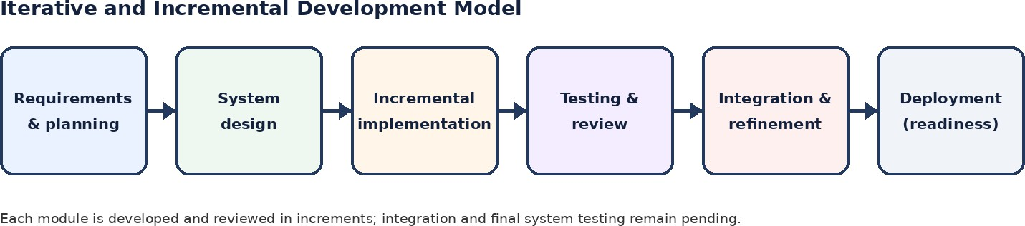

The documented development sequence includes topic finalization and planning, review of evaluation criteria, preparation and verification of documents, literature survey, approval of the implementation phase, review-paper preparation and submission, incorporating conference remarks, and discussion of implementation and further submissions.

Team Responsibilities

Team member | Responsibility
Anupam Kumar Singh | AI/NLP research, system architecture, backend and AI-assisted legal-information workflow.
Akshay Pratap Singh | Frontend development, authentication, user interface and lawyer-side functionality.
Prince Kumar | Database design, testing, documentation and system integration.

Performance Requirements
The system is intended to provide consistent request handling and a usable interface for client, lawyer and administrator roles. Future legal-query classification should be evaluated with documented datasets and reproducible procedures. The project material does not specify measured response-time, throughput, accuracy or availability targets; these should be defined during implementation and testing rather than assumed.
- Handle user registration, login and authenticated sessions.

- Enforce role-based access for CLIENT, LAWYER and ADMIN.
- Maintain lawyer profile information in the application database.
- Support future natural-language legal-query submission and category identification.
- Support future retrieval of approved legal information and referral to legal professionals.
- Record errors and protect sensitive user information.

System Features

Functional Requirements

ID | Requirement | Description / status
FR1 | User authentication | Register, log in and maintain authenticated sessions; current foundation.
FR2 | Role-based access | Separate CLIENT, LAWYER and ADMIN access; role-oriented foundation.
FR3 | Lawyer profile | Maintain lawyer-related profile information; lawyer-side functionality described in the evaluation material.
FR4 | Legal-query submission | Allow clients to describe legal concerns; planned.
FR5 | Legal classification | Identify relevant legal categories from natural-language input; planned.
FR6 | Informational guidance | Present preliminary information based on the identified category; planned.
FR7 | Lawyer referral | Help users find suitable legal professionals; planned.
FR8 | Lawyer availability | Allow lawyers to manage availability; planned.
FR9 | Consultation response | Allow lawyers to respond to consultation requests; planned.
FR10 | Administration | Administrative functions and user verification; implementation status must be confirmed.

Non-Functional Requirements

Requirement | Description
Security | Password hashing, authentication and role-based authorization.
Privacy | Protect sensitive user information; define access, retention and deletion practices before collecting legal-query data.
Usability | Simple, accessible interface for people without formal legal knowledge.
Maintainability | Modular frontend and backend to support independent development and updates.
Reliability | Consistent request handling and error management.
Scalability | Support future integration of AI and legal-information components.
Ethical safeguards | Clear disclaimers, source verification, uncertainty handling and appropriate human referral.

Project Constraints

Category | Major constraint | Possible mitigation
Economic | Initial development and cloud infrastructure costs | Use open-source tools and scalable infrastructure.
Economic | Legal-data digitization and skilled manpower | Plan data preparation and resource allocation.
Economic | Multilingual AI and cybersecurity expenditure | Stage development and prioritize security.
Environmental | High computing/energy use and data-centre footprint | Optimize models and use efficient infrastructure.
Environmental | Electronic waste | Responsible hardware lifecycle and authorized recycling.
Safety | Data breach and cyberattacks | Encryption, access control, secure APIs, monitoring and testing.
Safety | Incorrect AI output and bias | Source verification, dataset audits and human/legal review.
Sustainability | Outdated legal information and technology obsolescence | Continuous legal-content validation and modular upgrades.
Sustainability | Digital exclusion and vendor dependency | Accessible multilingual/low-bandwidth design and open standards.

Methodology
The proposed methodology is organized around the web application foundation and the planned legal-query processing workflow. The current system foundation provides authentication, role-based access and role-oriented dashboards. The additional AI workflow is proposed and requires implementation and evaluation.
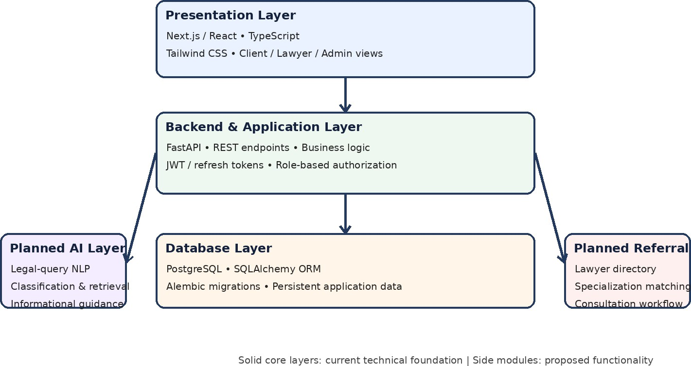

User Input and Interface
The intended client interface will allow users to describe a legal concern using ordinary language. The interface should avoid requiring users to know formal legal terms before submitting a concern. The frontend is specified as Next.js/React with TypeScript and Tailwind CSS.

Backend and Application Logic
The backend is specified as FastAPI with REST API endpoints. It is responsible for application logic, authentication and authorization. JWT and refresh tokens are specified for session and access management. The current backend foundation should be verified against the final source code before claims about specific endpoints are made.

Database Design
PostgreSQL is specified as the persistent data store. SQLAlchemy provides the ORM layer and Alembic is identified for database schema migrations. The evaluation presentation includes an ER diagram, while the project paper describes current PostgreSQL persistence and future storage needs for legal queries, classification histories and consultation records.

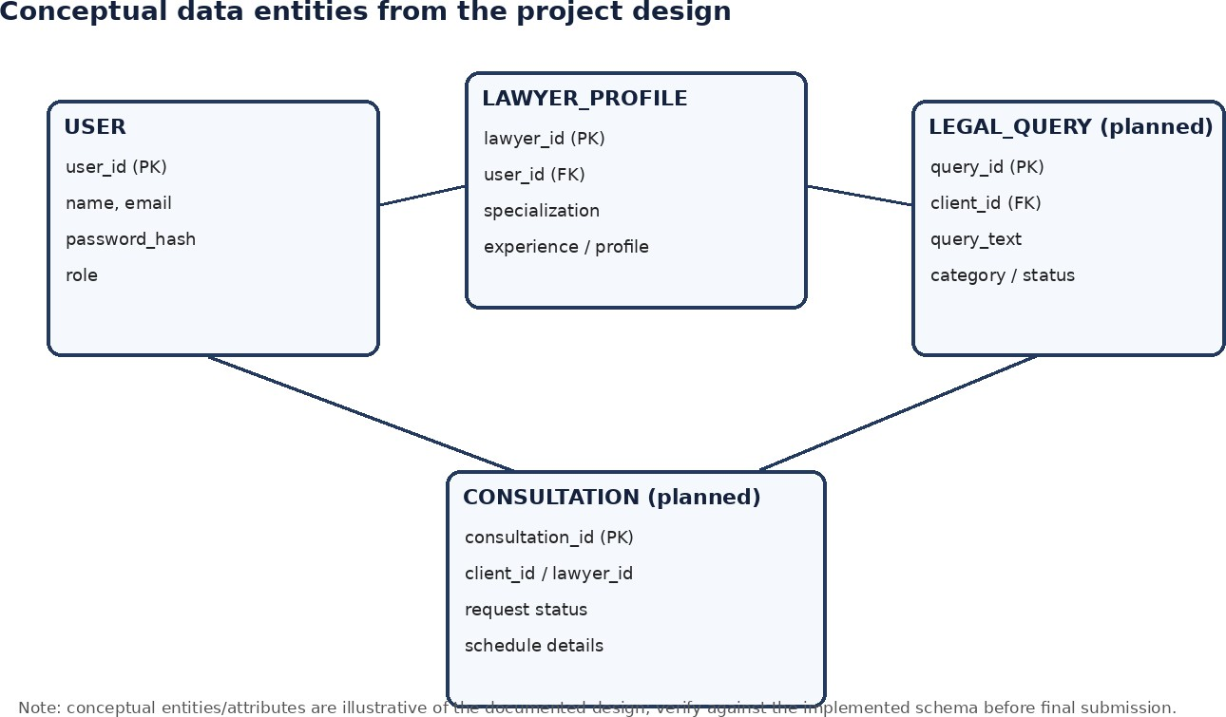

Natural-Language Processing and Classification (Planned)
The proposed classification component would process a user's ordinary-language description and estimate relevant legal categories or case types. Candidate baseline approaches include TF-IDF feature representation with Multinomial Naive Bayes and a linear Support Vector Machine. Model selection and hyperparameter tuning should follow the creation of a documented dataset and evaluation protocol.
A future dataset should define a legal-category taxonomy, source provenance, licensing and permitted use, annotation guidance and quality-control procedures. Real client inquiries would require appropriate authorization, de-identification and privacy review. Synthetic examples, if used, should be labelled and should not be treated as a substitute for representative real-world evaluation.

Knowledge Retrieval and Informational Guidance (Planned)
The planned guidance component would retrieve approved legal sources and present carefully scoped information in plain language. Each response should be traceable to its source. The system should not guarantee outcomes or make definitive legal conclusions. If the input is ambiguous or the system is uncertain, it should request clarification or direct the user to a qualified professional rather than provide an unsupported answer.

Lawyer Referral and Consultation (Planned)
The proposed referral component would help users locate legal professionals according to relevant profiles and specializations. The wider project design also identifies lawyer verification, searchable directories, matching, scheduling and consultation workflows as

future development items. These functions should be described as planned until endpoints, authorization rules and end-to-end behavior have been implemented and tested.
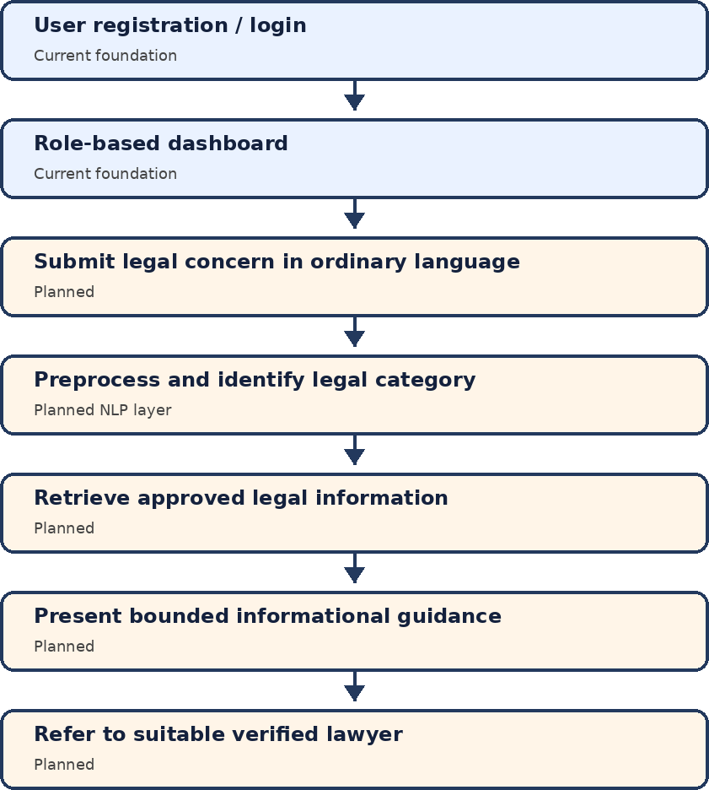

UML Use-Case View
The project identifies three principal actors: CLIENT, LAWYER and ADMIN. Client functions include registration, login and dashboard access, while legal-query submission, informational guidance and lawyer discovery are planned. Lawyer functions include login, dashboard access and profile management, while availability management and consultation responses are planned. Administrative functions include administrative access and user management/verification, with the latter marked as planned unless implementation is confirmed.

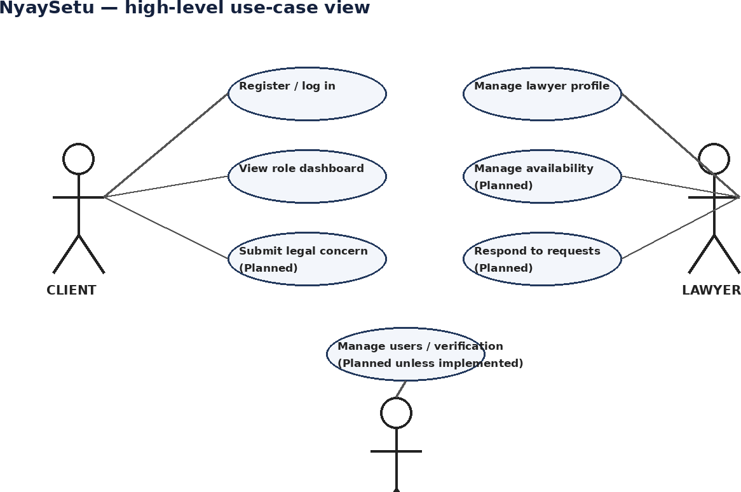

Testing Process
The project materials identify testing as a necessary activity for the frontend, backend, authentication, database and future AI components. The current research paper does not provide detailed test-case results or a complete end-to-end test report. Therefore, the following testing activities are recommended as a project verification plan, not represented as completed test outcomes.

Testing area | Suggested verification
Authentication | Check registration, login, token refresh, invalid credentials and session expiry.
Authorization | Verify that CLIENT, LAWYER and ADMIN can access only their permitted routes and functions.
API | Test request validation, response formats, error handling and unauthorized access.
Database | Verify schema constraints, relationships, migrations and persistence.
Privacy and security | Review password hashing, sensitive-data access, logging and retention/deletion rules.
AI classification (future) | Use a fixed train/validation/test split; report macro-F1, per-class precision/recall and confusion matrix.
Guidance (future) | Check source traceability, factual scope, disclaimers and uncertainty handling.
Referral (future) | Verify lawyer profile accuracy, matching rules and consultation workflow.

The final testing report should record test identifiers, preconditions, input data, expected output, actual output, pass/fail status, date and responsible tester.

CHAPTER 4: RESULTS AND OUTPUTS

CHAPTER 4 RESULTS AND OUTPUTS

Current Implementation Status
The supplied research paper and Evaluation 2 presentation distinguish the established application foundation from planned AI and lawyer-referral functionality. The report therefore records the available status without treating proposed modules as completed.

Component / activity | Status supported by source material
Project planning and literature review | Completed / documented.
System requirements and architecture | Documented.
Frontend authentication shell | Described as current foundation.
Protected routes and role-oriented dashboards | Described as current frontend work.
FastAPI backend and PostgreSQL persistence | Described as current technical foundation.
Authentication and role-based access | Described as current foundation.
Natural-language legal-query interface | Not yet implemented beyond the existing shell.
Legal-query dataset and annotation | Not yet assembled/reported.
TF-IDF + Naive Bayes / linear SVM training | Proposed; no NyaySetu model results reported.
Grounded legal-information retrieval and response | Planned; implementation and evaluation required.
Lawyer verification, matching and consultation workflow | Future development items.
End-to-end testing and user evaluation | Not reported as completed.

Architecture and Design Outputs
The architecture output organizes the system into presentation, backend, database and planned AI layers. The presentation layer uses Next.js/TypeScript and Tailwind CSS. The backend layer uses FastAPI and REST endpoints for authentication, authorization and application logic. The database layer uses PostgreSQL, SQLAlchemy and Alembic. The planned AI layer includes natural-language preprocessing, legal-query classification, knowledge retrieval and informational guidance.
The system design also identifies client, lawyer and admin actors. Client and lawyer dashboards are part of the role-oriented design. Query submission, legal guidance, lawyer discovery, lawyer availability and consultation response are marked as planned in the Evaluation 2 presentation.

Requirements and Progress Summary
The project has progressed from topic finalization and literature review to requirements definition, architecture design, review-paper preparation and the initial web-application foundation. The meeting records in Evaluation 1 document ten mentor interactions from January to August 2026.

Week | Date | Discussion / meeting details

1 | 26/01/2026 | Topic finalized and project workflow planning discussed with mentor.
2 | 02/04/2026 | Progress, evaluation criteria and initial documentation preparation reviewed.
3 | 05/04/2026 | Documents verified; corrections and improvements suggested by mentor.
4 | 08/04/2026 | Literature survey process and related research papers discussed.
5 | 15/04/2026 | Zeroth evaluation documents reviewed and implementation phase approved.
6 | 20/06/2026 | Review paper discussed; adding a Result and Discussion section was suggested.
7 | 27/07/2026 | Required changes completed and review paper submitted.
8 | 10/08/2026 | Conference remarks discussed; a comparative graph was suggested.
9 | 17/08/2026 | Suggested changes and comparative graph completed; modified paper submitted.
10 | 24/08/2026 | Implementation approach and further conference submissions discussed.

Discussion and Limitations
    - Dataset dependency: a representative labelled legal-query dataset has not yet been assembled. The project cannot claim classifier accuracy before data collection, annotation and evaluation.
    - Jurisdiction sensitivity: legal categories and information may vary by jurisdiction. The system must establish the relevant jurisdiction and use appropriately scoped, validated sources.
    - Vocabulary mismatch: everyday descriptions may differ substantially from formal legal language. Dataset design should include naturally phrased queries and document the limitations of synthetic examples.
    - Incorrect or incomplete output: AI-generated information may be incomplete or misleading. Source verification, uncertainty handling and human professional referral are essential.
    - Privacy and security: legal concerns may contain sensitive personal information. Data minimization, role-based access, retention and deletion practices require review before collection.
    - Bias and class imbalance: underrepresented legal categories or user groups may produce unequal performance. Dataset audits and per-class evaluation are required.
    - Implementation boundary: classification, grounded guidance and lawyer matching are planned. They must not be represented as live or validated functionality until verified.
    - Testing and adoption: usability, response quality, trust and user outcomes have not been empirically established in the supplied materials.

CHAPTER 5: CONCLUSION

CHAPTER 5 CONCLUSION

Conclusion
NyaySetu is a proposed AI-assisted legal-information and lawyer-referral platform intended to make preliminary legal information easier to approach. It addresses barriers arising from limited legal awareness, economic constraints, geographical access and complex procedures. The project is designed around the idea that users should be able to describe their concerns in ordinary language rather than first learning formal legal terminology.
The documented technical foundation combines a Next.js/TypeScript frontend, FastAPI backend, PostgreSQL persistence, authentication and role-based access. The system design separates these established foundations from planned legal-query classification, grounded informational guidance and lawyer-referral functionality. Candidate classification approaches include TF-IDF with Multinomial Naive Bayes and a linear SVM, but no NyaySetu-specific dataset or model evaluation results are currently reported.
The project establishes a structured basis for further implementation through its literature review, research gap, requirements, architecture, conceptual database design and iterative development approach. Its eventual value will depend on reliable engineering, legally appropriate source material, privacy safeguards, clear disclaimers, human professional involvement and evaluation with representative users. NyaySetu is intended to provide general information only and does not replace advice from a qualified lawyer.

Future Scope
    - Prepare a documented legal-category taxonomy and assemble a lawful, representative, labelled legal-query dataset with annotation quality controls.
    - Implement and compare baseline classifiers such as TF-IDF with Multinomial Naive Bayes and linear SVM; report macro-F1, class-wise precision/recall and confusion matrices.
    - Evaluate transformer-based legal language models only after establishing a reproducible baseline and appropriate computing/data resources.
    - Implement a natural-language query interface with clarification and abstention for ambiguous or low-confidence inputs.
    - Build a knowledge base of approved legal sources with source tracking, update procedures and jurisdiction-aware retrieval.
    - Implement bounded plain-language informational responses with clear disclaimers and a pathway to qualified legal professionals.
    - Complete lawyer verification, searchable profiles, specialization matching, availability and consultation workflows.

    - Conduct security, privacy, accessibility and usability testing, including review by qualified legal professionals.
    - Extend accessibility through multilingual support and low-bandwidth design where feasible.
    - Integrate all modules, complete end-to-end testing and evaluate the system with representative users before any deployment.

CHAPTER 6: REFERENCES

CHAPTER 6 REFERENCES
- F. Sebastiani, “Machine learning in automated text categorization,” ACM Computing Surveys, vol. 34, no. 1, pp. 1–47, 2002.
- J. Devlin, M. W. Chang, K. Lee, and K. Toutanova, “BERT: Pre-training of deep bidirectional transformers for language understanding,” in Proceedings of NAACL-HLT, 2019, pp. 4171–4186.
- I. Chalkidis, E. Fergadiotis, P. Malakasiotis, N. Aletras, and I. Androutsopoulos, “Legal-BERT: The muppets straight out of law school,” in Proceedings of EMNLP, 2020, pp. 2898–2904.
- D. Jurafsky and J. H. Martin, Speech and Language Processing, 3rd ed. Pearson, 2023.
- S. Bird, E. Klein, and E. Loper, Natural Language Processing with Python. O’Reilly Media, 2009.
- A. Vaswani et al., “Attention is all you need,” in Advances in Neural Information Processing Systems, 2017, pp. 5998–6008.
- T. Mikolov, K. Chen, G. Corrado, and J. Dean, “Efficient estimation of word representations in vector space,” in Proceedings of ICLR Workshop, 2013.
- Scikit-learn developers, “Scikit-learn: Machine learning in Python,” Journal of Machine Learning Research, vol. 12, pp. 2825–2830, 2011.
- Legal NLP researchers, “A survey of legal text classification,” bibliographic details not specified in the supplied evaluation presentation.
- Various researchers, “Legal text processing and classification,” bibliographic details not specified in the supplied evaluation presentation.
- Various researchers, “Conversational AI systems,” bibliographic details not specified in the supplied evaluation presentation.
- K. S. K. S. N. Kumar and A. Singh, “Detecting smishing attacks using NLP and machine learning,” IEEE Transactions on Cybersecurity, vol. 8, no. 3, pp. 245–258, 2024. (Listed in the supplied research paper; relevance to legal NLP is indirect.)
- P. Verma and S. Rao, “Privacy assessment in Android apps: A systematic review,” Computers & Security, vol. 108, 2021. (Listed in the supplied research paper.)
- V. Choudhary and M. Patel, “Automated privacy requirement analysis in mobile apps,” IEEE Software, vol. 34, no. 4, pp. 48–55, 2017. (Listed in the supplied research paper.)

- M. Lewis et al., “BART: Denoising sequence-to-sequence pre-training for natural language generation, translation, and comprehension,” in Proceedings of ACL, 2020, pp. 7871–7880. (General NLP background; not a NyaySetu implementation.)

ANNEXURE-I

- 1- Meeting details –

Eval 0
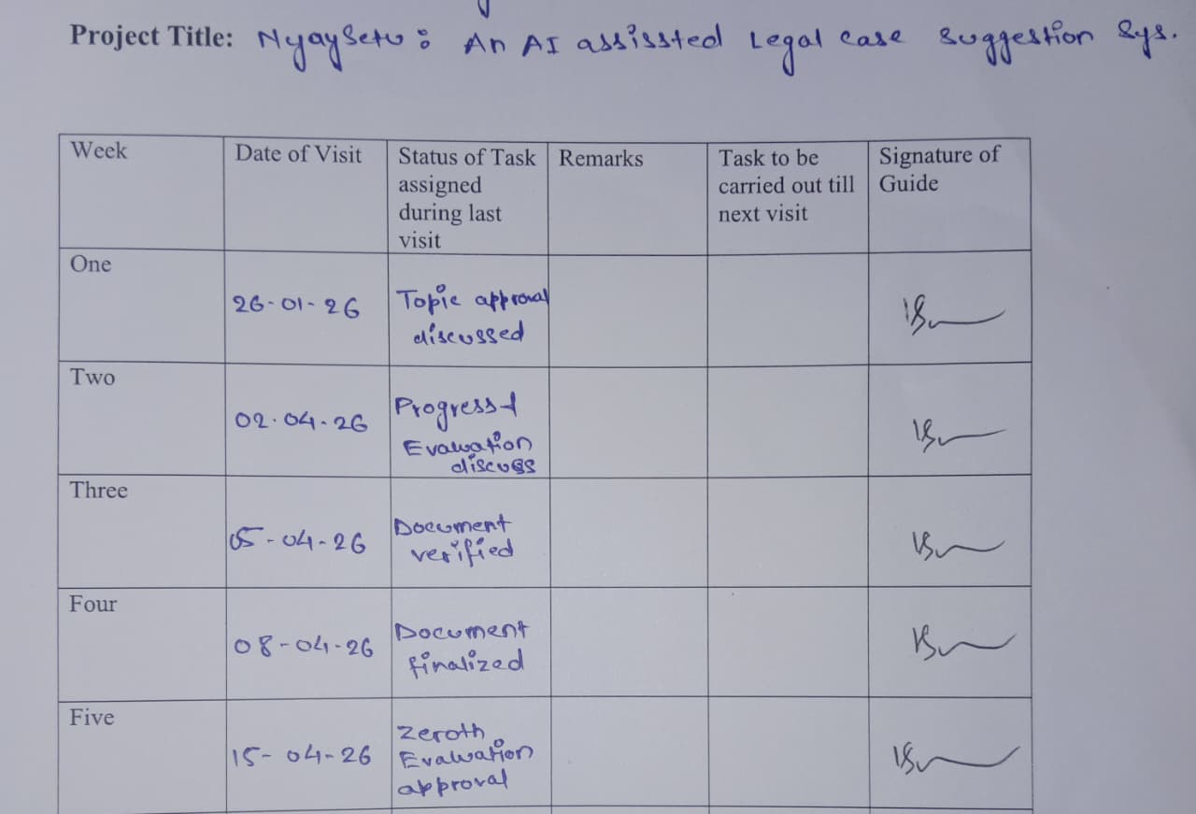

Eval 1




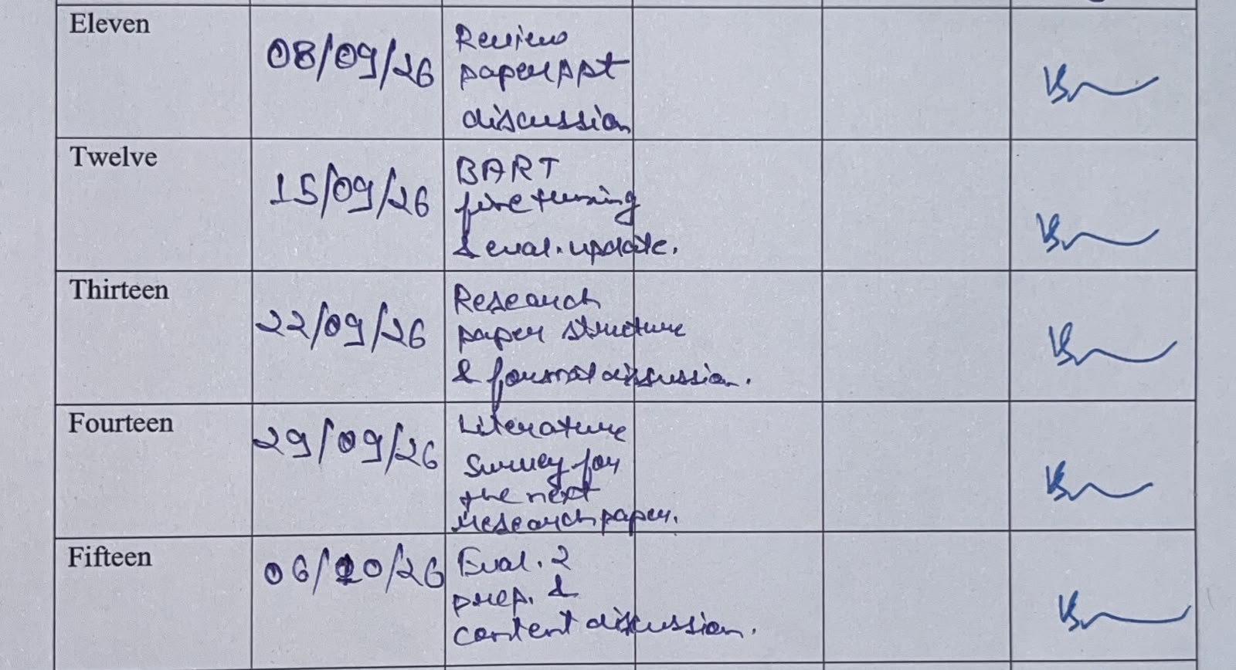
Eval 2

  - Eval 3:

ANNEXURE-II

Submission:
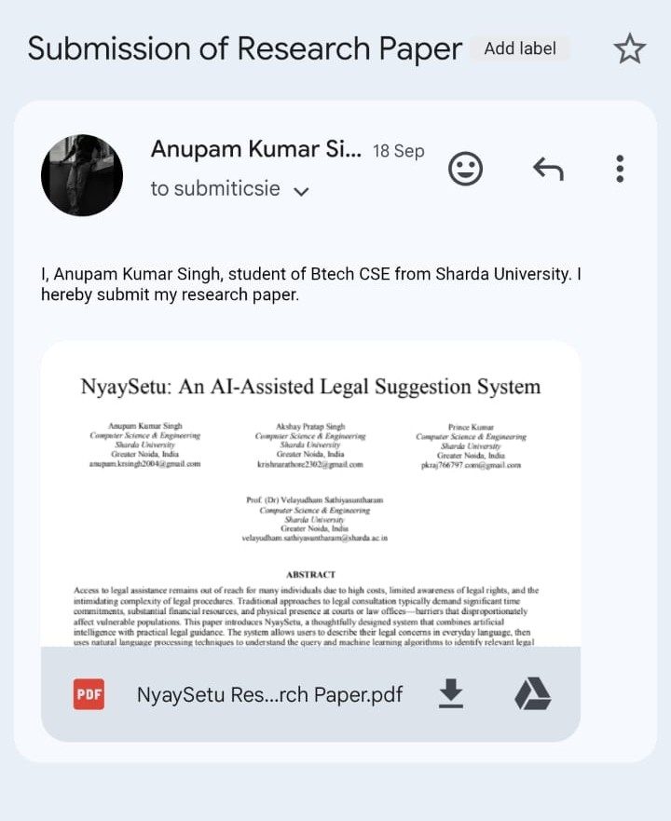

- Acceptance

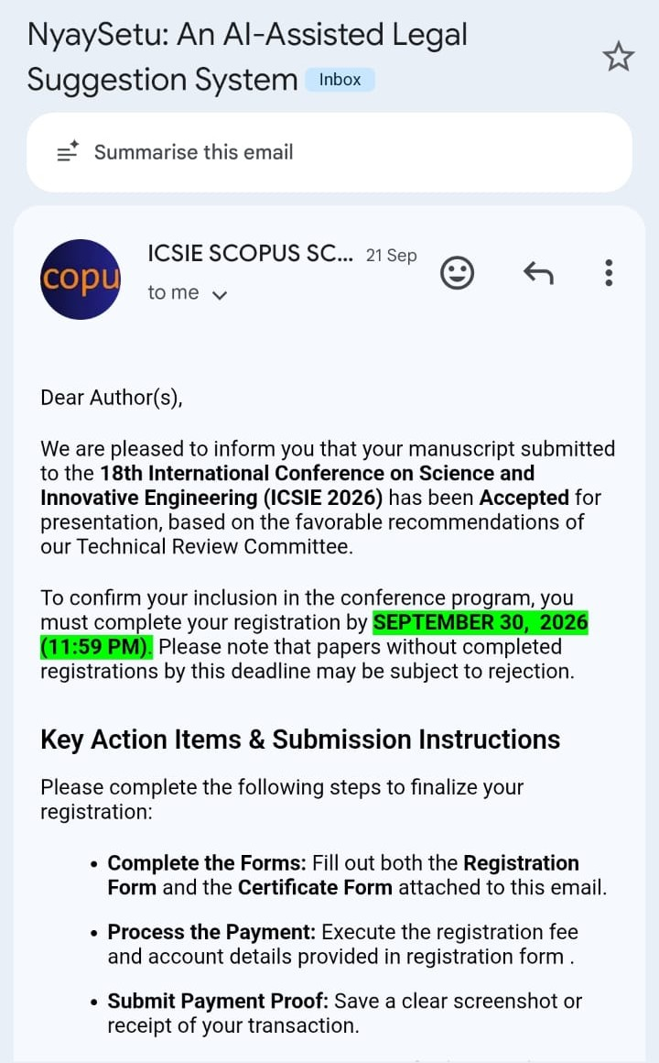

- Registered:



